DIGITAL CLOCK  
CSCI212-LOGIC GATES

Under the supervision of

Dr. Walaa Medhat Asal

Made by

NAME: ID:

|  |  |
| --- | --- |
| **Youssef Hassan Abdelmaksoud** | **211002056** |
| **Michael Wagdy Wahib** | **211001776** |
| **Ziad Moataz Samy** | **211001556** |
| **Alaa Hassan Hassan** | **19105762** |

INTRODUCTION  
  
 The clock is a device that displays the current time and updates automatically. and it is typically used for timekeeping purposes. In our project, we have implemented a clock that resets when it reaches 59 seconds. This means that the clock will start over again from 0 seconds once it reaches 59 seconds.

The stopwatch is a device that is used to measure the time elapsed between the start and stop of an event. In our project, we have implemented a stopwatch that allows the user to input a number and have the clock's LED remain on for that duration of time. This allows the user to use the stopwatch as a timer for specific events or tasks.

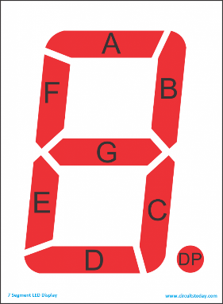Truth table

|  |  |  |  |  |  |  |  |
| --- | --- | --- | --- | --- | --- | --- | --- |
| Digit | A | B | C | D | E | F | G |
| 0 | 1 | 1 | 1 | 1 | 1 | 1 | 0 |
| 1 | 0 | 1 | 1 | 0 | 0 | 0 | 0 |
| 2 | 1 | 1 | 0 | 1 | 1 | 0 | 1 |
| 3 | 1 | 1 | 1 | 1 | 0 | 0 | 1 |
| 4 | 0 | 1 | 1 | 0 | 0 | 1 | 1 |
| 5 | 1 | 0 | 1 | 1 | 0 | 1 | 1 |
| 6 | 1 | 0 | 1 | 1 | 1 | 1 | 1 |
| 7 | 1 | 1 | 1 | 0 | 0 | 0 | 0 |
| 8 | 1 | 1 | 1 | 1 | 1 | 1 | 1 |
| 9 | 1 | 1 | 1 | 1 | 0 | 1 | 1 |

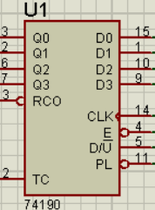

|  |  |  |  |  |  |
| --- | --- | --- | --- | --- | --- |
| PL | Q0 | Q1 | Q2 | Q3 | RCO |
| 0 | 0 | 0 | 0 | 0 | 0 |
| 0 | 1 | 0 | 0 | 0 | 0 |
| 0 | 0 | 1 | 0 | 0 | 0 |
| 0 | 1 | 1 | 0 | 0 | 0 |
| 0 | 0 | 0 | 1 | 0 | 0 |
| 0 | 1 | 0 | 1 | 0 | 0 |
| 0 | 0 | 1 | 1 | 0 | 0 |
| 0 | 1 | 1 | 1 | 0 | 0 |
| 0 | 0 | 0 | 0 | 1 | 0 |
| 0 | 1 | 0 | 0 | 1 | 0 |
| 0 | 0 | 0 | 0 | 0 | 1 |
| 0 | 0 | 0 | 0 | 1 | 0 |
| 1 | D0 | D1 | D2 | D3 | 0 |

|  |  |  |  |  |
| --- | --- | --- | --- | --- |
| Q0 | Q1 | Q2 | Q3 | U5-A |
| x | x | x | 1 | 1 |
| x | x | 0 | 0 | 1 |
| x | 0 | 1 | 0 | 1 |
| 0 | 1 | 1 | 0 | 0 |

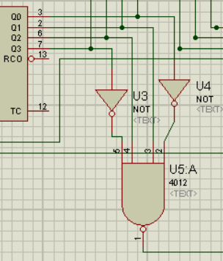  
  
  
  
  
  
  
  
  
  
  
  
  
  
  
  
  
Conclusion

In conclusion, your project involves building a clock and stopwatch device that combines the functionality of both timekeeping devices. The clock resets when it reaches 59 seconds, while the stopwatch allows the user to input a number and have the LED remain on for that duration of time. To implement these features, you are using the 74190 IC, which is a decade counter with a 4-bit binary coded decimal (BCD) output. This IC is known for its reliability, low power consumption, and ease of use, making it well-suited for use in your project. Overall, your project is a useful and versatile timekeeping device that combines the features of a clock and a stopwatch in a single device.